FACULTY EVALUATION
Programme Name: Resource Mobilization Programme
Session: Introduction to Resource Mobilization
Faculty Name: Beatrix Masime
No. of Respondents: 16
No. of Participants: 16
Evaluation Parameter | (%) Individual Score | (%) Programme Average
Punctuality | 96 | 96
Clarity of presentation | 91 | 94
Degree of preparation | 89 | 94
Course design & org | 86 | 91
Content & methodology | 90 | 93
Quality of discussions | 88 | 94
Relevance to work | 92 | 95
Average scores | 90 | 94

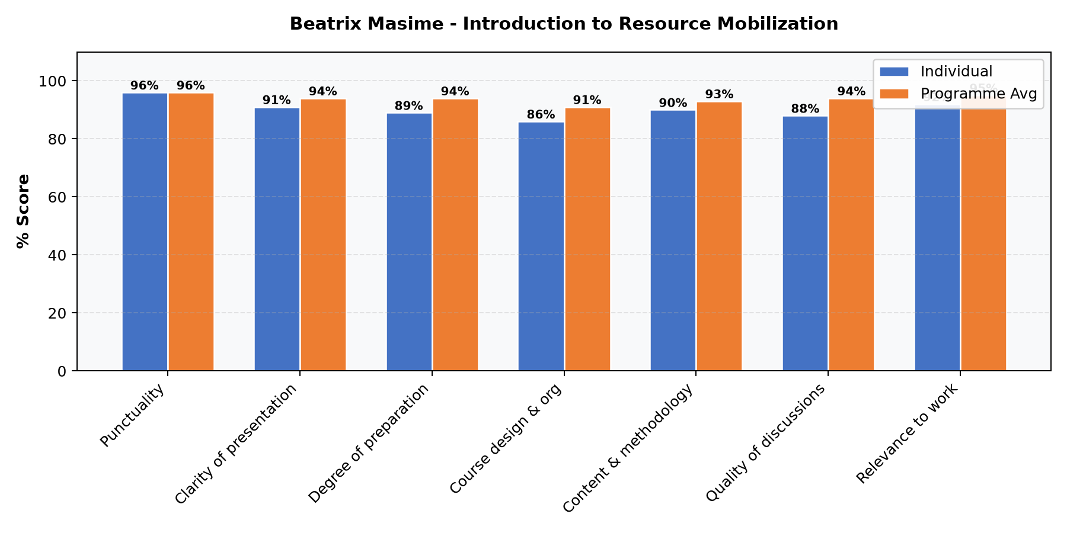

Comments & Feedback
- • Well delivered
- • In depth knowledge to the course shared and it was a wonderful opportunity to have the links to resource mobilization networks at the end of the class
- • Improve the powerpoints on color and font
- • The introduction to the course provided great insights about resource mobilization
SUBMITTED THROUGH:
NAME: ______________________ SIGN: ______________________ DATE: ______________________

